LIOHER  FULL SHEET PANELS · EDGE BANDING · DIY PROJECT MATERIALS | Premium surface panels & matching edge banding  for your DIY project.  3 COLLECTIONS - LUXE - ZENIT - SYNCRON
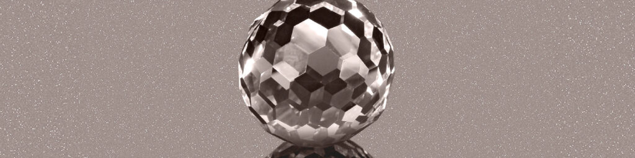
LUXE · HIGH GLOSS · MIRROR FINISH

The latest generation of lacquered surfaces delivers a mirror-effect high gloss finish with the highest scratch resistance in the industry. Perfect for modern kitchens, vanities, and commercial projects that demand a luxurious, reflective surface.
- Available as full sheet panels for DIY builds
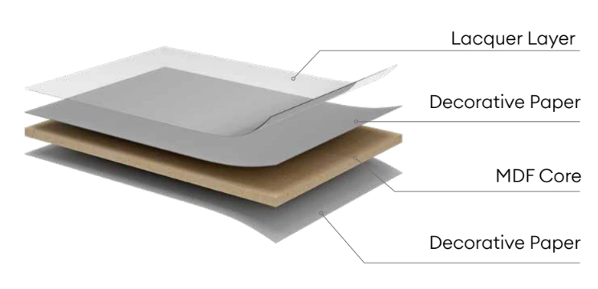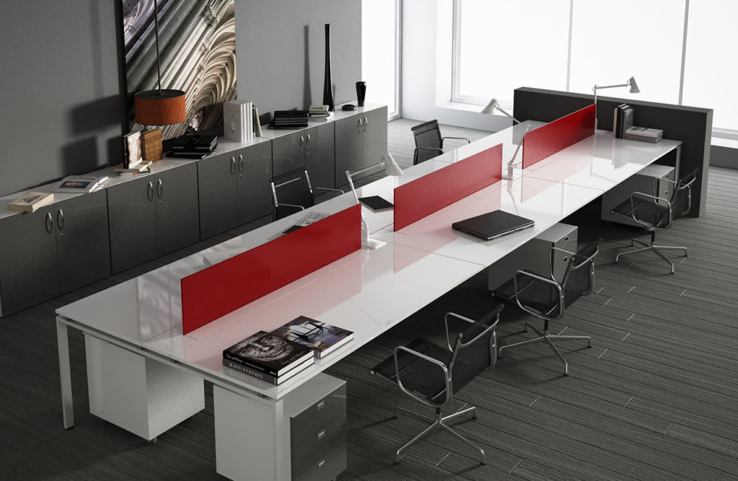

- Solid colors, wood grains, metallics & stone designs
- Kitchen, bath, commercial & residential use
- Matching high gloss edge banding available
Sample Finishes (Several more colors available — ask our team for free samples)
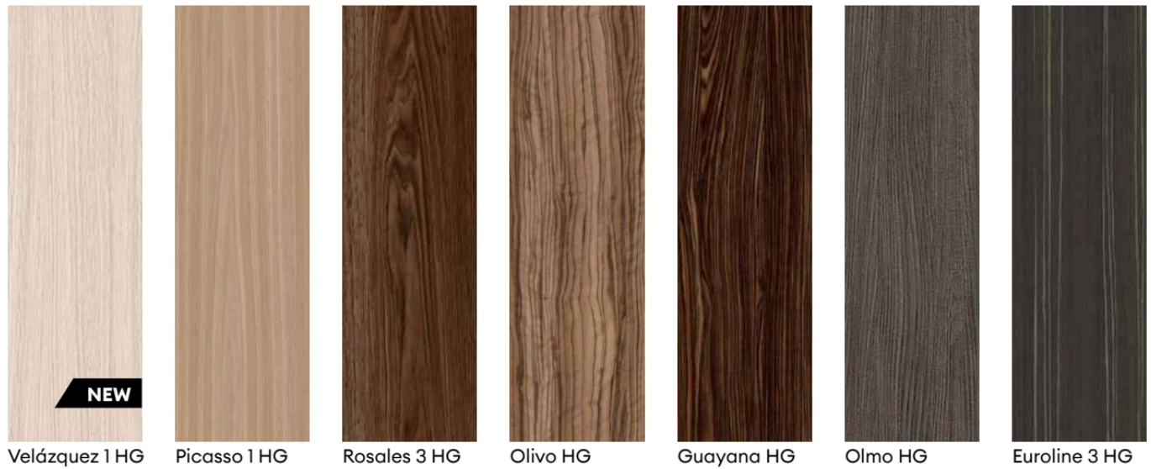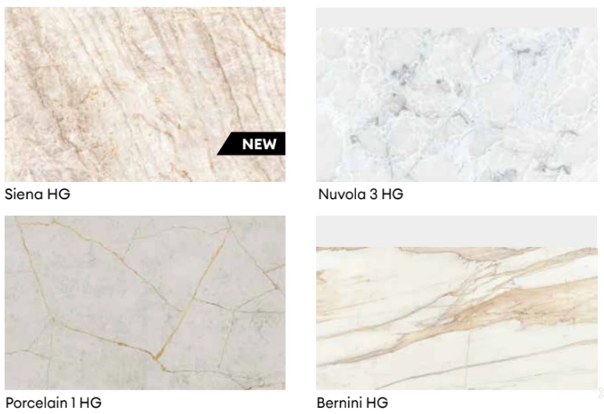


ZÉNIT · SUPER MATT · SILKY TOUCH

A deep supermatt surface with a silky feel and extraordinary abrasion resistance. Available in solid colors with or without metallic particles, plus elegant marble and stone designs — ideal for contemporary matte kitchens and custom furniture.
- Available as full sheet panels for DIY builds
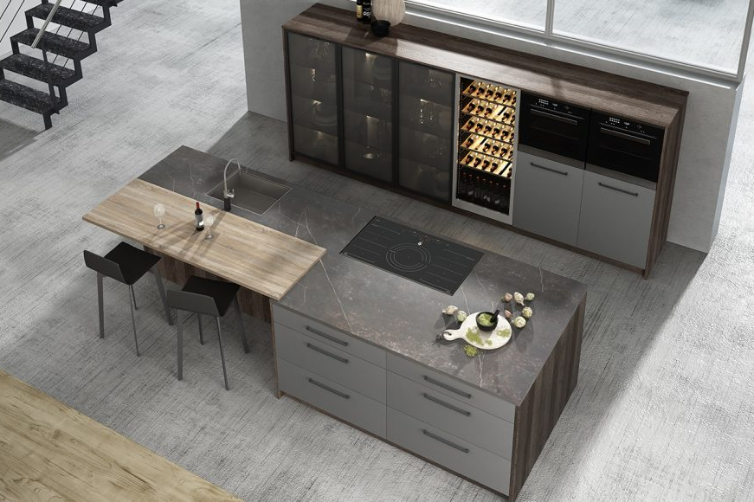

- Solid & metallic particle colors
- Marble & stone designs available
- Matching edge banding available

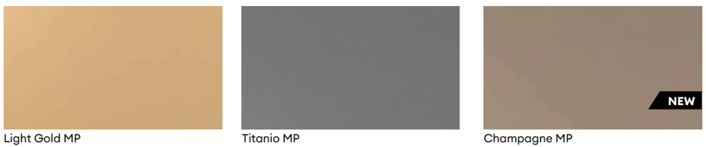
Sample Finishes (Several more colors available — ask our team for free samples)
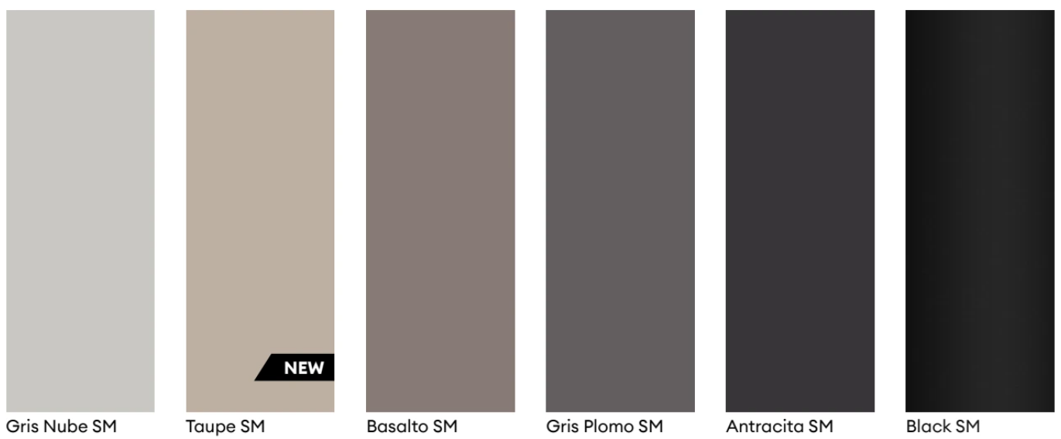

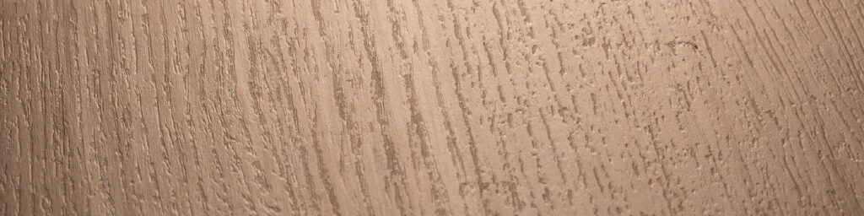

SYNCRON · TEXTURE · NATURAL FINISH

Highly decorative and textured surface — a true match between the tactile surface and the printed design for complete realism. The most lifelike natural finishes available for DIY cabinetry, furniture, and millwork projects.
- Available as full sheet panels for DIY builds
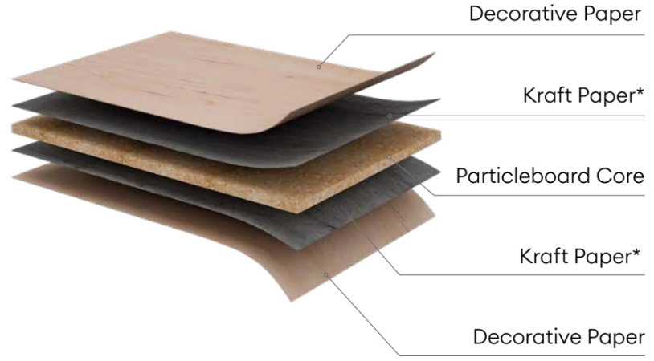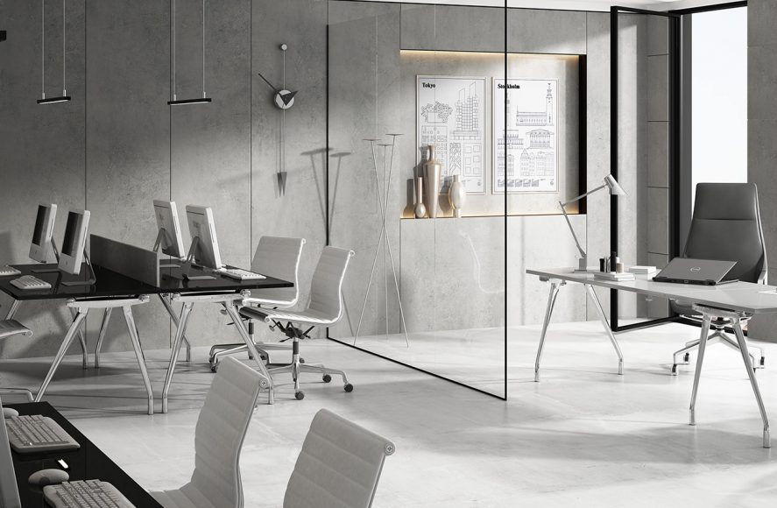

- Wood grain, stone, concrete, leather & textile finishes
- Registered texture-to-grain match technology
- Matching edge banding for clean, professional edges

Sample Finishes (200+ available — ask our team for the full sample board)
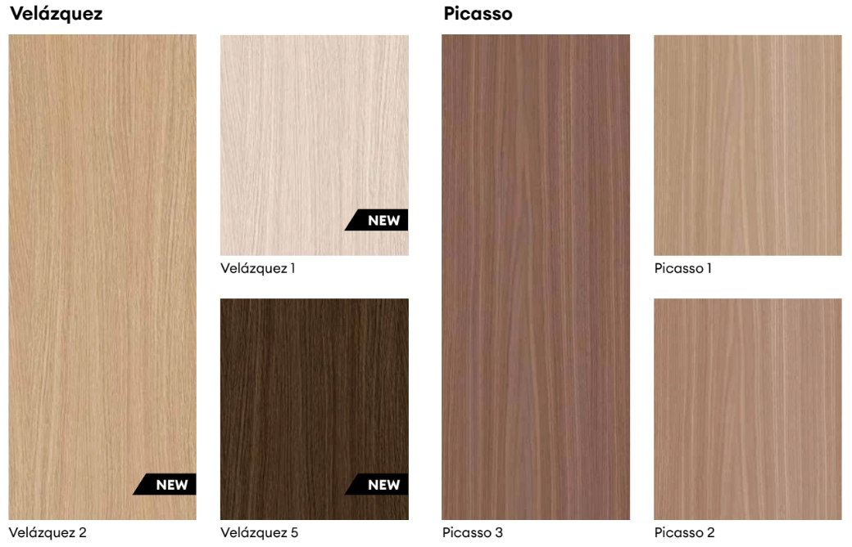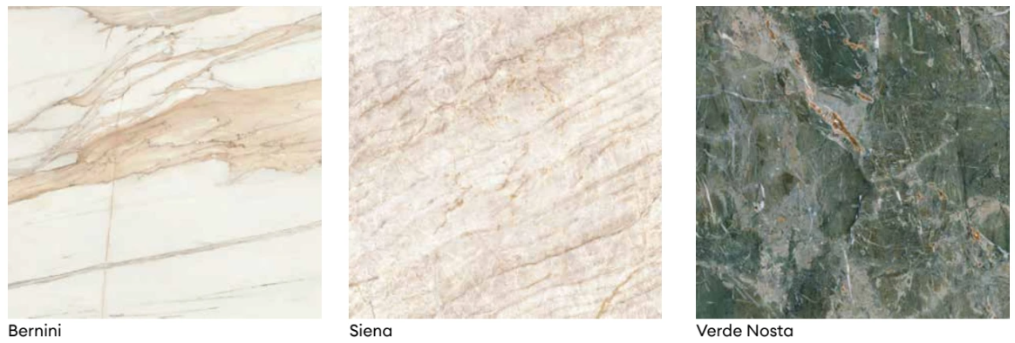

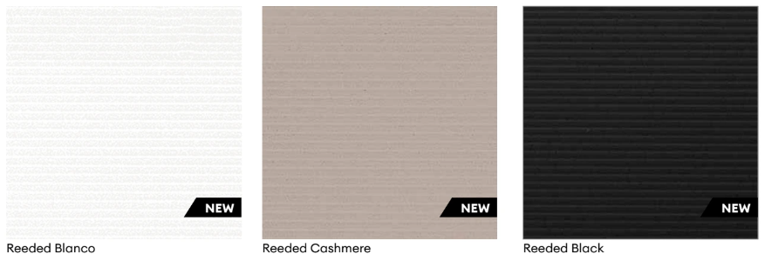

EDGE BANDING
Color-Matched Edge Tape
Every LIOHER panel collection offers precisely matched edge banding tape. Options include standard PVC in 7/8” or 1-1/2” rolls of banding. Finish your DIY project cleanly and professionally on every side.
- Standard PVC edge banding
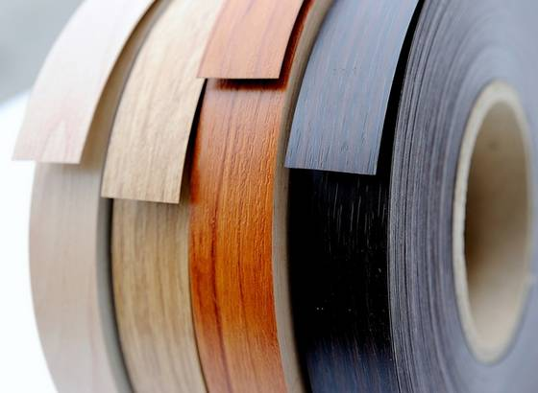
- 50 ft. to 738 ft. length options
- 7/8” or 1-1/2” width options
- Sequence grain match for realistic wood designs
- Compatible with all LUXE, ZÉNIT & SYNCRON finishes

 | OUR TEAM | Jasen Huebsch  Manager / Studio Sales  Jasen@studiosupplier.com | Rick Garay  Studio Sales  Rick@studiosupplier.com | Marco Torres  Studio Sales  Marco@studiosupplier.com | HOURS  Mon–Fri  6:30am–4:30pm

6322 W. Slauson Ave. · Culver City, CA 90230  (310) 839-5215 · Fax (310) 572-1015  studiosupplier.com · Info@studiosupplier.com | Your DIY project deserves a professional finish.  5-Year Warranty · lioher.com · Open a Trade Account

